Maximum marks for Assignment: _________6______ Assignment Declaration Date:____________
Assignment Submission Date (on or before):______________________________
Assignment assessment declaration Date by faculty (on or before):________________________
Q. NO | Question Statement | Level of mapping and Number |  |  | Blooms Level | Marks
Q. NO | Question Statement | CO | PO | PSO
Q1. | Describe key elements of Total Quality Management | CO5 | PO1 |  | 1 | 3
Q2 | Explain Product Quality Metric and Process Quality Metrics. | CO5 | PO1,  PO2 |  | 2 | 4
Q3 | Explain need of Software maintenance | CO5 | PO2,  PO3 |  | 2 | 4
Q4 | List ishikawa’s 7 basic tools | CO5 | PO1 |  | 3 | 3
Q5 | Explain following terms (any two) Pareto Chart Scatter Diagrams Cause and effect diagrams | CO5 | PO2,  PO3 |  | 3 | 4
Q.6 | Use of histogram in test quality of product or project | CO5 | PO4 |  | 3 | 4
Q.7 | Describe in detail Defect Removal Effectiveness | CO5 | PO1 |  | 2 | 4
Q.8 | Explain use of Scatter diagram ,checklist | CO5 | PO1,  PO2 |  | 2 | 4
Q.9 | List Ishikawa’s 7 Basic tools and Explain any 2 tools | CO5 | PO4,  PO5,  PO11 |  | 2 | 6
Blooms level no | Blooms Taxonomy terms
6 | 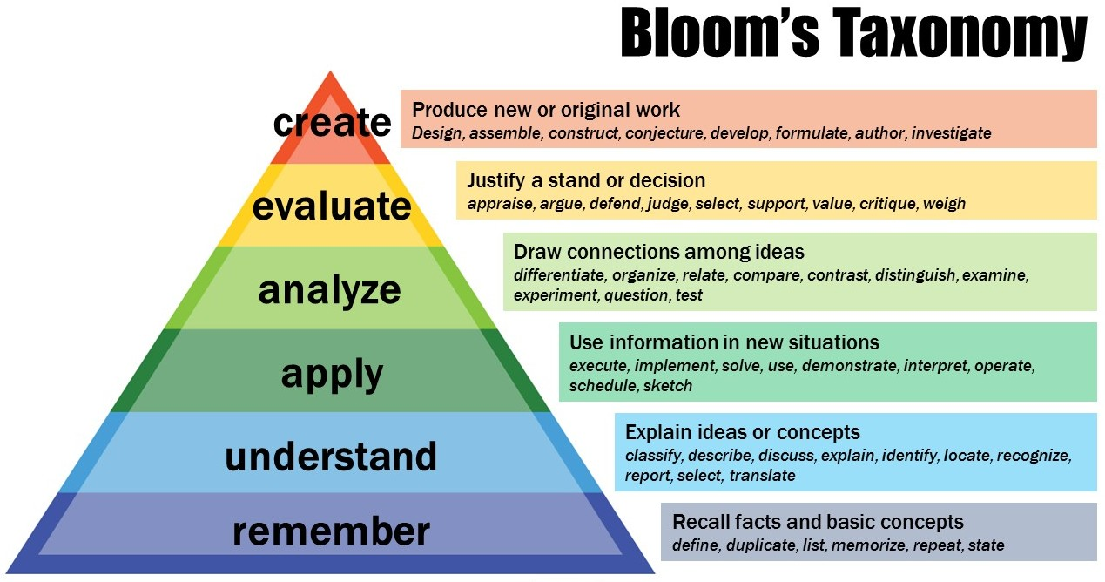
5
4
3
2
1

Subject In-charge HOD

